The hidden spire creative collective (Old Fire Station)

A hidden thing : A secret about St. Catherine’s College

The small area of pencil marks on a brick wall of St. Catherine’s College, now some 60 years old, can be seen if you know where to look. Their meaning, however, is hidden unless I tell their story.

I should first say that I am a retired director of Ove Arup and Partners, joining them after I graduated in 1958, which coincidentally was around the year that Arne Jacobsen (a Dane) was appointed as the architect for this new Oxford College. Today, this would hardly raise an eyebrow, but in 1959 the idea of a plum appointment going to a non-National ruffled a few feathers in the architectural establishment. Jacobsen brought with him some continental ideas, such as the use of ‘long’ bricks with a quarter bond, very non-English but very elegant, as the picture shows. He visited regularly to inspect the progress of the work, and on one visit was critical of the standard of construction of the early panels of brickwork; specifically the alignment of the perpends (the short vertical joint between the bricks). The story, according to Arup lore, is that on site the brickies explained their difficulties to Jacobsen. Now the Danish architectural course is exceptionally long and includes a large degree of practical work. Jacobsen picked up a trowel, buttered a brick with mortar, and laid it precisely in position, followed by a few more, saying ‘I mean like this,’ and he recommended that the perpends should be set out from the course but one below, making pencil marks to illustrate the principle. The brickies must have learnt from this, because the standard of workmanship is incredibly high generally.

In his mammoth work ‘the Buildings of England’ (the Oxfordshire volume) the architectural historian Nikolas Pevsner commences his description of the College with the sentence ‘Here is a perfect piece of architecture’. Such a compliment from such a distinguished observer of the architectural scene carries all before it, and the ‘Johnny Foreigner’ critics have generally given in, after visiting the building, which was Listed Grade 1 in 1993.

And the pencil marks – a blue plaque maybe?

Peter Ross BSc DIC MICE   Associate Director (Retired) ARUP

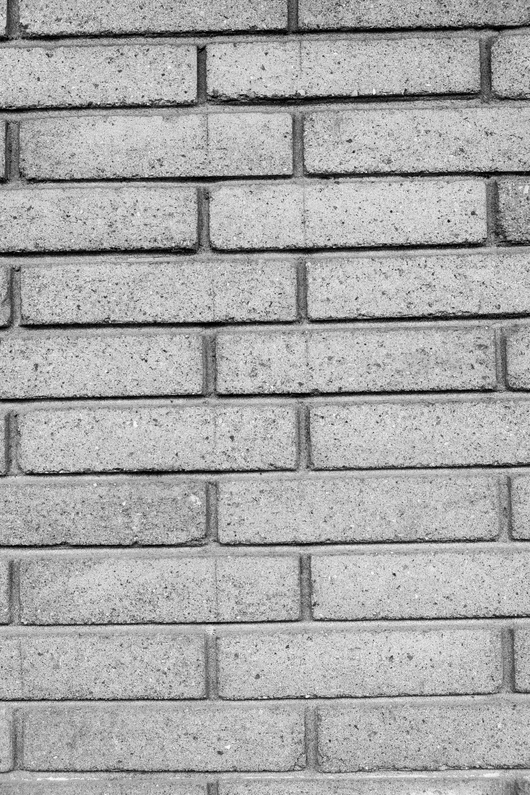

Photograph by ©Cathy Lewis, Peter’s daughter.